Homework 1 - KNN Matting

311551096 錢承

1. KNN

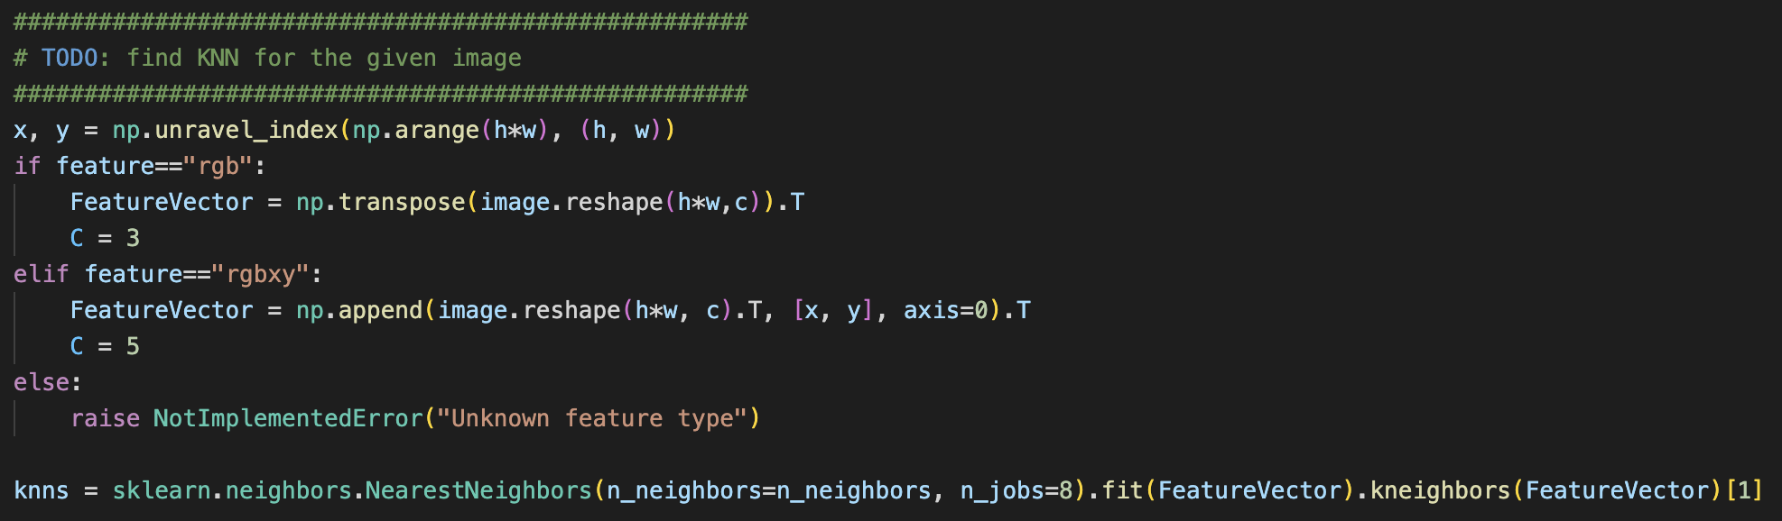

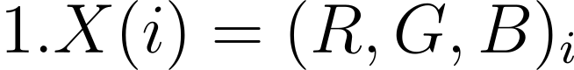



Before calculating the KNN, I will first determine two feature vector kinds. The first kind of feature vector includes R, G, and B values of each pixel. The second kind of feature vector includes R, G, B, x, and y. The second kind of feature vector also includes x and y coordinates to grab more local information instead of only color information

1. Affinity Matrix

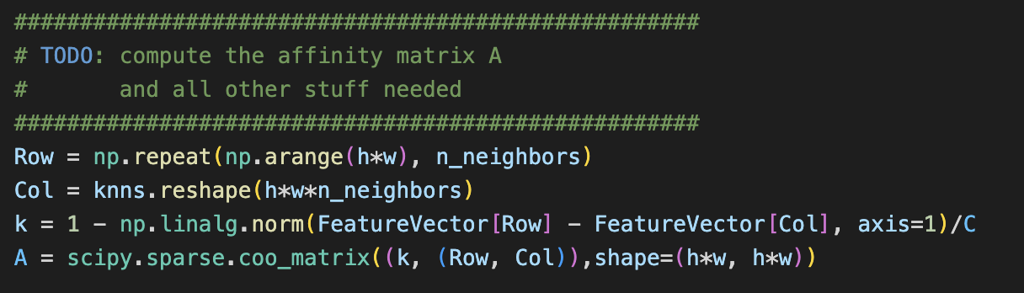

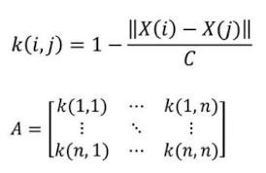

After calculating the KNN, I calculated the affinity matrix. First, I generated the x index and the y index and then calculated the kernel function. Finally, I generated an affinity matrix by using the index.

1. Solving for the Linear System

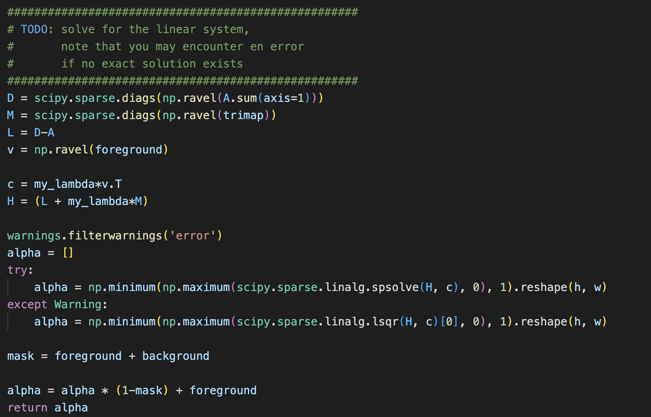

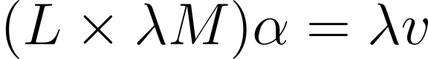

Here I am solving the linear system above. First, I calculate the D, M, L, and v. D is a diagonal matrix content with the sum of the affinity matrix at axis 1. M a diagonal matrix content with the Trimap. And v is the foreground.

1. Merge Image with the Foreground

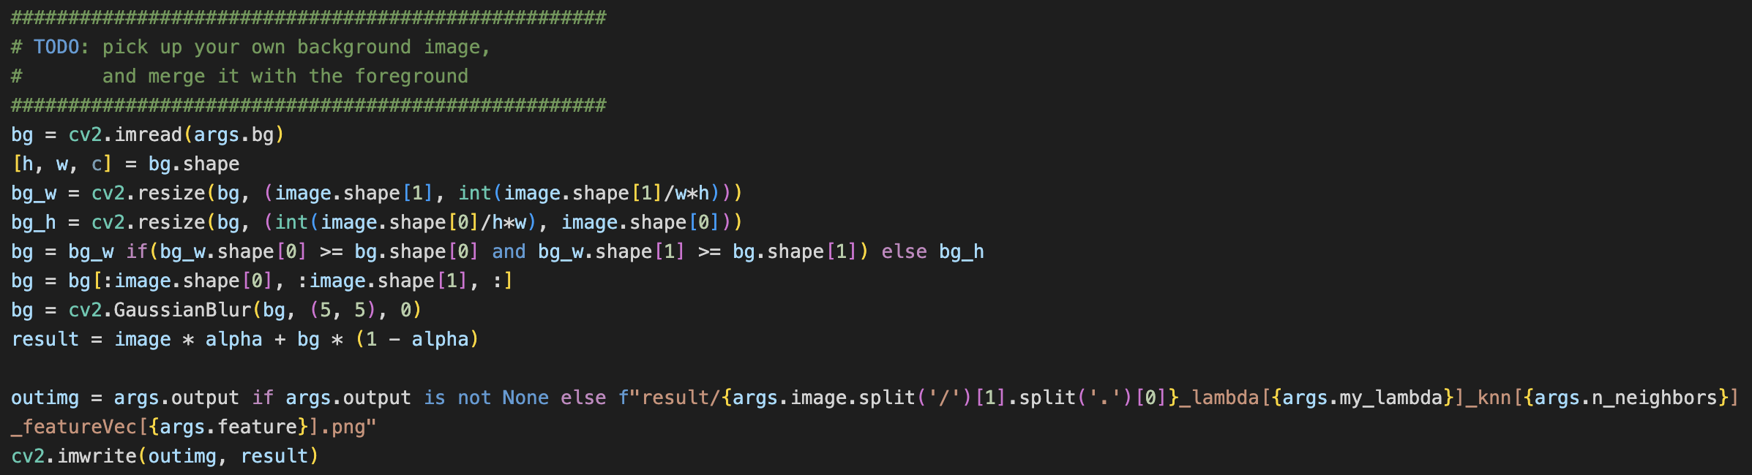

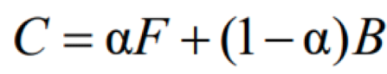

To merge the background image with the foreground image, I first resize and crop the background image to the same size as the foreground image. Then add the Gaussian Blur to the background to make the merged image more natural. Last, combine the foreground and the background image together by using the $α$.

1. Result

* Lambda = 50, knn = 5, Feature Vector = (R, G, B, x, y)

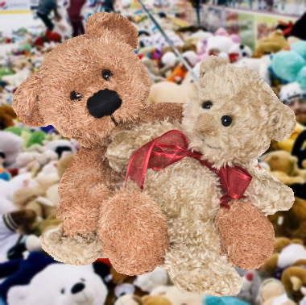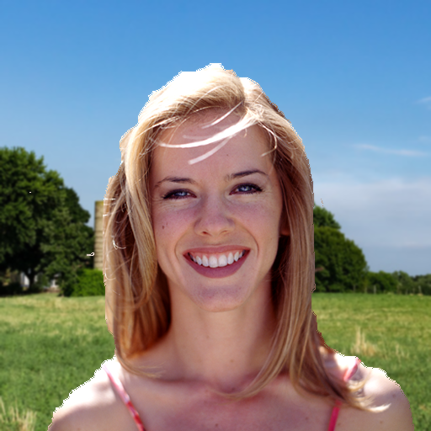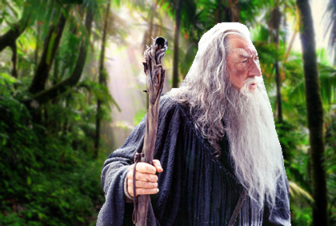

* Lambda = 50, knn = 10, Feature Vector = (R, G, B, x, y)

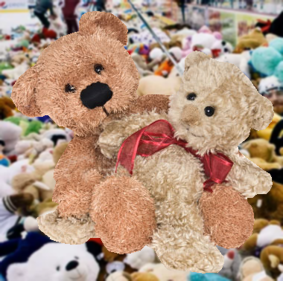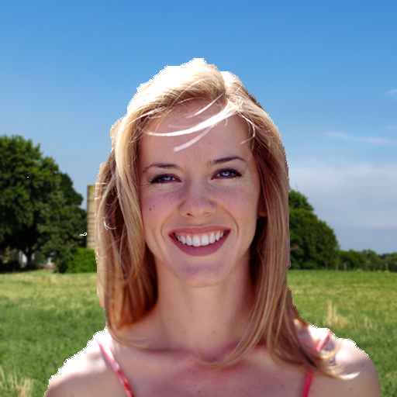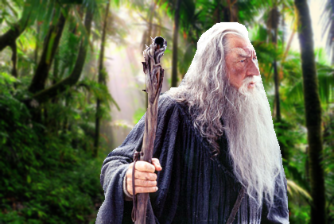

* Lambda = 50, knn = 20, Feature Vector = (R, G, B, x, y)

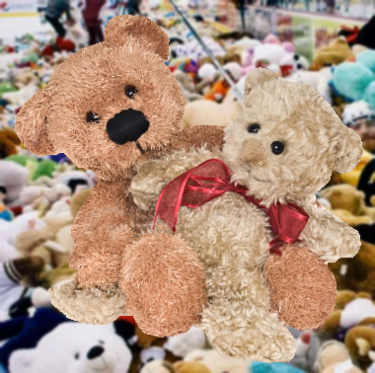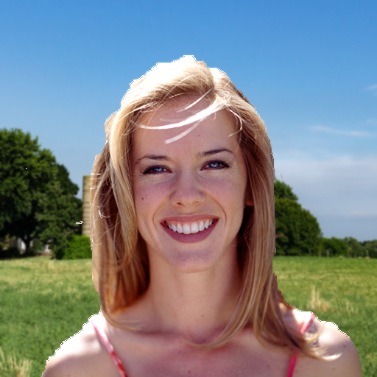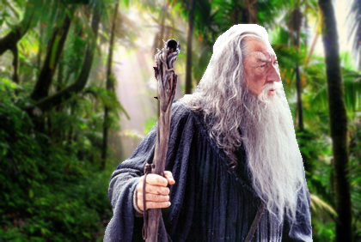

* Lambda = 50, knn = 40, Feature Vector = (R, G, B, x, y)

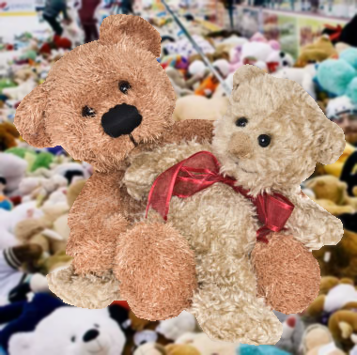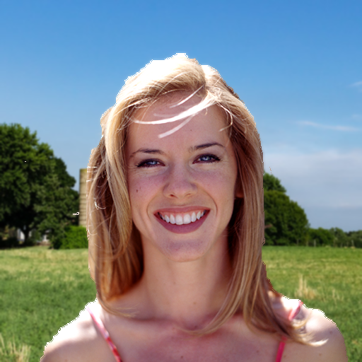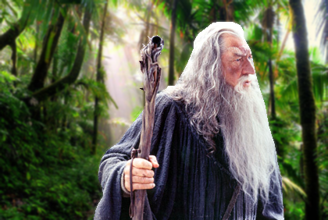

* Lambda = 30, knn = 10, Feature Vector = (R, G, B, x, y)



* Lambda = 80, knn = 10, Feature Vector = (R, G, B, x, y)

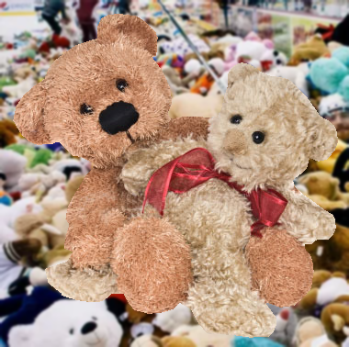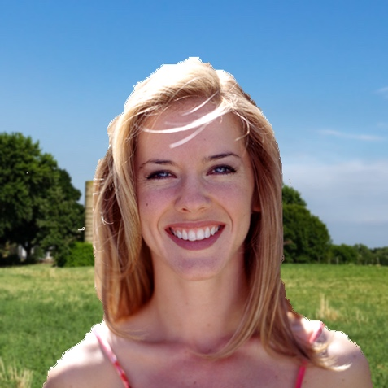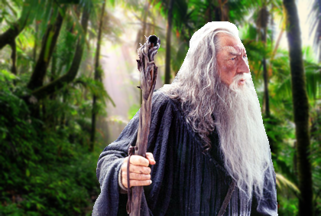

* Lambda = 50, knn = 5, Feature Vector = (R, G, B)

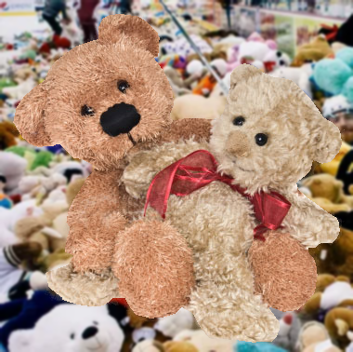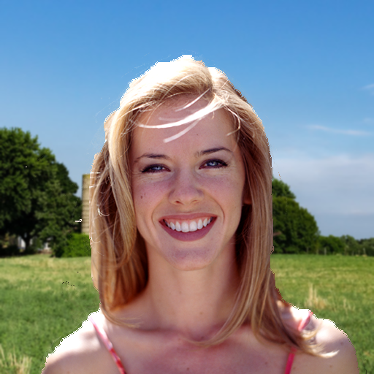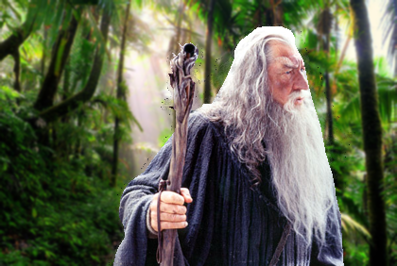

* Lambda = 50, knn = 10, Feature Vector = (R, G, B )

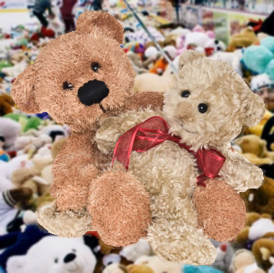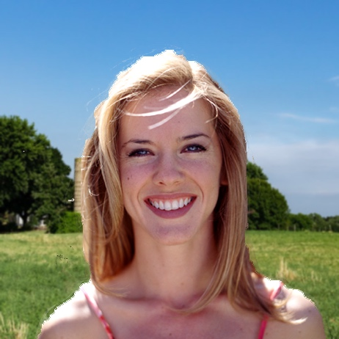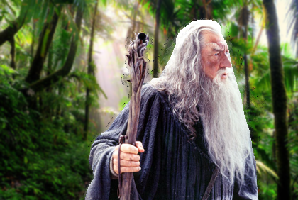

* Lambda = 50, knn = 15, Feature Vector = (R, G, B)

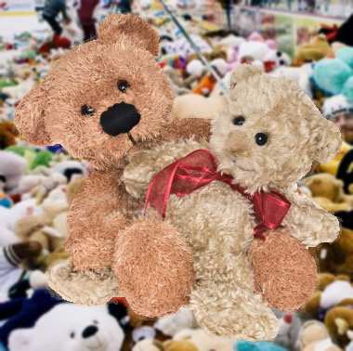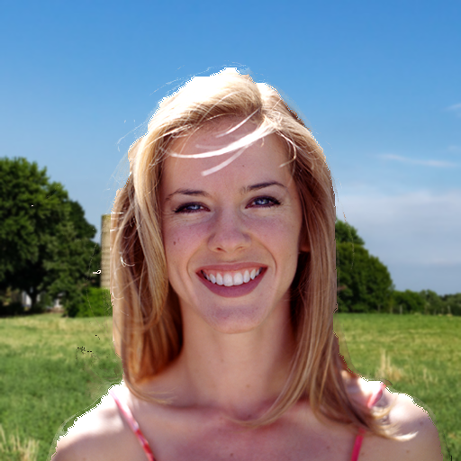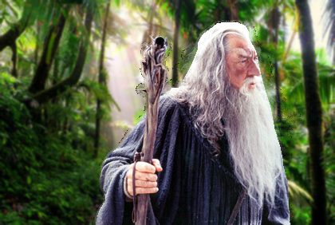

I try two of the feature vectors, including the x and the y coordinates, and not. We can see that if the feature vector didn’t include the x and the y coordinates, there would be significant artifacts on the image.

1. Code Usage

$ python3 -u 311551096_code.py --image {Foreground image path} --trimap {Trimap image path} --bg {Background image path} --output {Output image path} --my_lambda {lambda value} --n_neighbors {knn value} --feature {Feature vector type, rgbxy or rgb}

1. References

* https://github.com/MarcoForte/knn-matting